Comparison
F102 NSPC001
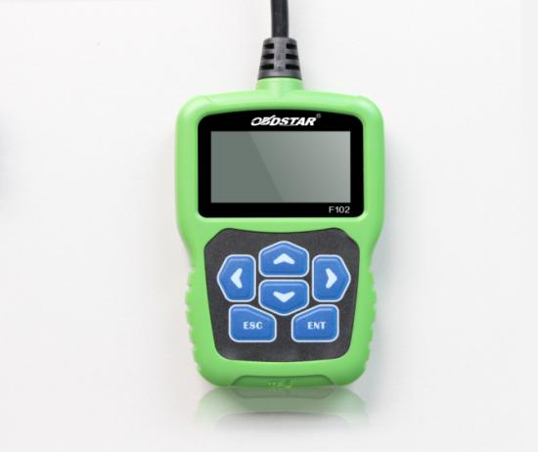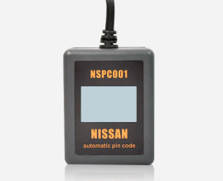

Features & Functions | OBDSTAR F102 | NSPC001
Support to read BCM codes of all Nissan/Infiniti cars. | √ | √
Can transfer 5-digit code to 4-digit code and 20-digit code to 20 digit code. | √ | √
No need to connect with computer, plug and play, automatic transfer. | √ | √
Program Keys for most of Nissan/Infiniti cars.（not all） | √
Correct Mileage for most of Nissan/Infiniti cars.（not all） | √
No need to buy tokens. | √
One Key Upgrade | √
Have good man-machine interaction. | √
With 100 point built-in tokens. |  | √
No deduction for 5-digit code to 4-digit code. |  | √
One point will be deducted for each success transfer of new 20-digit code to 20-digit code and successful reading of BCM code. |  | √
When 100 tokens used up, you can still use it to get 4-digit code, but you need to buy a new  one if you want to read new 20-digit pin code. |  | √

