Yanhua key features and advantages
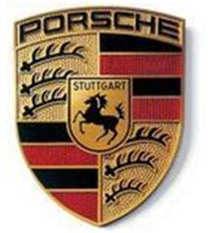
- Key matching way
- The common Mercedes Benz key matching way in the market:
Steps: take apart the Mercedes Benz key, remove the NEC CPU from the key board and weld it onto the device board, write key before remove the NEC CPU and weld it back to the key board, finally assemble the key.
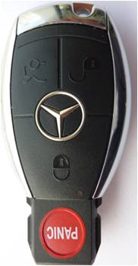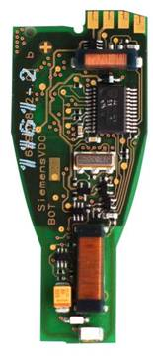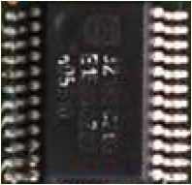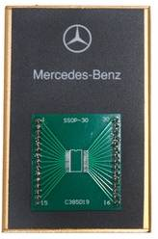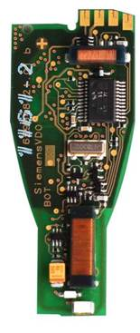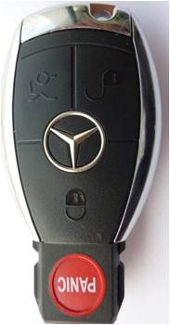
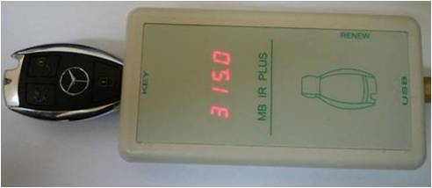
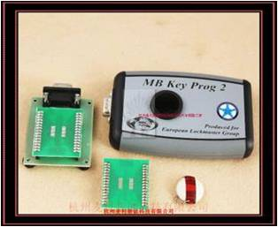
- the steps to match Yanhua key:
Steps: Correctly put the Mercedes Benz key into the infrared adapter, and write key.
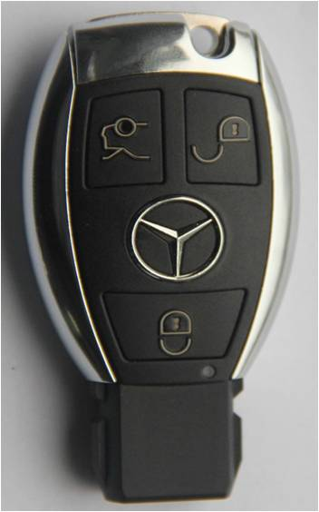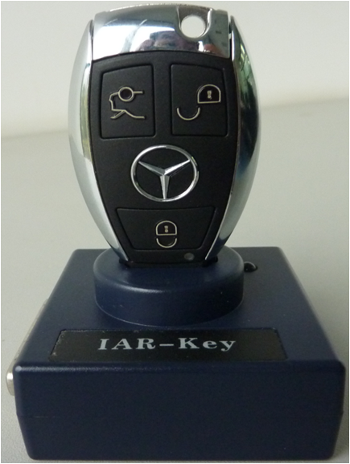

- The common key matching way VS Yanhua key matching way
- Operation:
The common Mercedes Benz key matching way read, write and erase data by remove the Mercedes Benz NEC chip, the procedure is complicated and it demands higher welding technology.
On the contrary, Yanhua key complete read and write by infrared way without need to take apart the key and weld the chip, the procedure is not complicated and it demands lower welding technology.
- Risk:
Since the common Mercedes Benz key matching way demands higher welding technology, improper operation will lead to higher risk of taking apart and welding the key. It also has another uncertain risk that the NEC chip is easily get broken during the procedure of removing, especially after many times operation of key reading and writing, when the NEC chip is broken the whole key is useless.
- Repeatedly use:
Because the common key matching way has a complicated procedure, and has higher risk as the second point said, a part of key even cannot repeatedly use.
On the contrary, Yanhua key can repeatedly read and write key by infrared, especially the ESL make the identification of the key fault more convenient and faster.

- Quality guarantee:
Because the Mercedes Benz key sold in the market is the second hand of the original, but you are informed the key is original. After you take apart the key and the risk is undertook by yourself, you are not allowed to return for a new one.
On the contrary, Yanhuan key provide free replacement in the period of warranty, to protect the users’ interests and reduce the risk.

3, Key shell
- YH Mercedes Benz key design and manufacturing features:
- YH Mercedes Benz key shell adopt the imported high-performance composite material, whatever the hardness, comfort, feel or quality is as good as the original product.
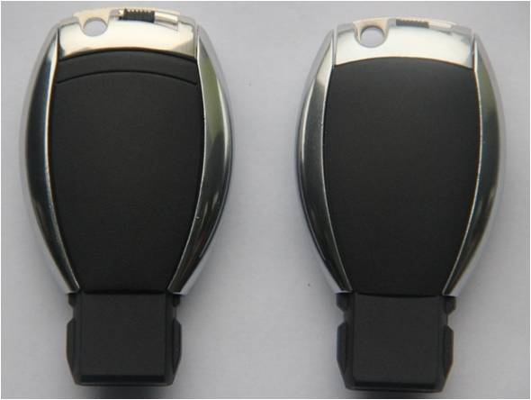
- The decorative parts adopt the imported vacuum ultrathin plating process, compared with the same kind products it is higher gloss and wear resistant, which fully reflect the combination of the high quality, high-precision molds and double molding process.
- The key button is designed according to the newest Mercedes Benz model, which make YH key button feel more comfortable and has a long life expectancy compared with the same kind products, many times press button will not lead to key shell has dent and perforation.
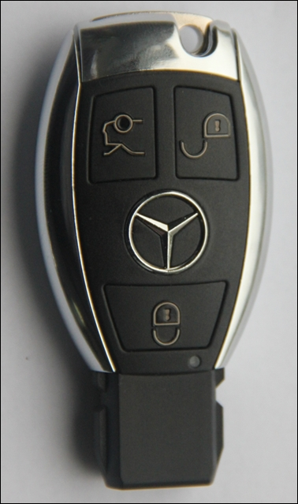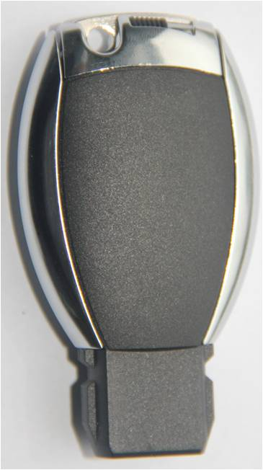
2) YH key shell and the same kind key shell comparison in details:
A. The key button advantages:
The key button adopt the new key design way, every button adopt the hard plastic and independently connected with the shell, compared with the older version soft key shell, the newest key button is more comfortable.
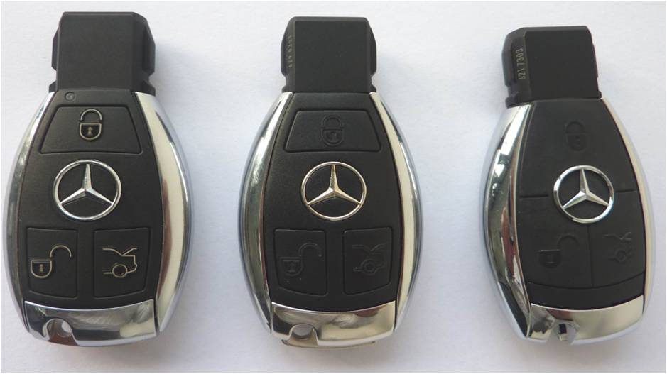
- Construction advantage:
YH key shell has higher goodness of fit, smaller gap and keep fine visual look and feel.
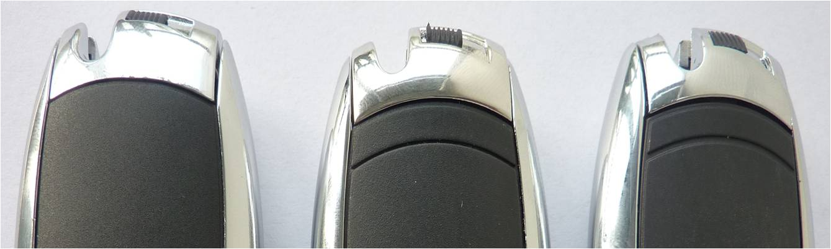
- The closer contact of battery and shrapnel ensure the battery room and the key circuit board more reliable contact.
